PROJECT DOCUMENTATION
WEBSCRAPING IN FLIPKART USING
MACHINE LEARNING

TITLE: | WEBSCRAPING IN FLIPKART USING MACHINE LEARNING
NAME: | Gunaseelan.C
COURSE: | DA/DS, Offline
BATCH: | JUNE 2025

TABLE OF CONTENT

1 | INTRODUCTION
2 | AIM OF THE PROJECT
3 | PROBLEM STATEMENT
4 | WEB SCRAPING
5 | DATA UNDERSTANDING
6 | DATA CLEANING
7 | EXPLORATORY DATA ANALYSIS (EDA) - UNIVARIATE
8 | BIVARIATE ANALYSIS
9 | MULTIVARIATE ANALYSIS
10 | SQL CONNECTIVITY
11 | UNSUPERVISED LEARNING
12 | SUPERVISED LEARNING
13 | HYPERPARAMETER TUNING
14 | PREDICTION & CONCLUSION

INTRODUCTION
This project performs an end-to-end data science workflow using real-world e-commerce product data obtained through web scraping. After extracting product details from an online shopping platform, the dataset undergoes multiple stages, including cleaning, analysis, database storage, clustering, supervised modelling, and prediction.
The project demonstrates a complete pipeline combining:
- Python Web Scraping
- Data Wrangling and Cleaning
- Exploratory Data Analysis (EDA)
- SQL Database Integration
- Machine Learning (Unsupervised & Supervised)
- Model Tuning and Prediction
This showcases practical data science skills applicable to e-commerce analytics, market research, and recommendation systems.

AIM OF THE PROJECT
To build and analyse an e-commerce dataset scraped from the web and develop machine learning models for product segmentation and predictive insights. The objective is to:
- Automatically collect live product information
- Clean and prepare data for modelling
- Discover product patterns using clustering
- Build ML models for predicting product-related attributes
- Evaluate and compare model performance

PROBLEM STATEMENT
E-commerce platforms contain high-volume product data without downloadable datasets. Efficient collection, cleaning, and analysis are challenging. This project aims to:
- Extract structured product information from a website
- Standardise and preprocess scraped data
- Identify pricing and rating patterns
- Predict product behaviour using ML
- Provide insights useful for business decisions like pricing strategy & product positioning
WEB SCRAPING
Web scraping was implemented to collect real-time product listings, including:
- Product Name
- Price & MRP
- Rating
- Discount details
Technologies Used
- requests — Send web requests
- BeautifulSoup — Parse HTML
- pandas — Store extracted data
- time — Delay requests to avoid blocking
Key Steps
- Crawl website pages with user-agent headers
- Parse page source and identify HTML selectors
- Extract and validate each product attribute
- Append extracted fields into structured lists
- Convert lists into a DataFrame
- Save dataset as CSV

Scalability
Pagination logic implemented to scrape multi-page results, enabling large-scale dataset creation.
DATA UNDERSTANDING
After importing the scraped CSV into the working environment, the dataset was carefully explored to gain a deep understanding of its structure, content, and potential data quality challenges. This step served as the analytical foundation for further cleaning, modelling, and decision-making.
Initial Assessment
- Loaded dataset using pandas.read_csv()
- Inspected dataset size using df.shape to check the number of rows and columns
- Viewed first and last few rows (df.head(), df.tail()) to examine raw structure
- Checked column names, data types, and memory usage via df.info()
Data Quality Checks
- Verified unique product categories using df['Category'].unique() and nunique()
- Validated basic numeric distributions for price, discount, and rating using df.describe()
- Analysed summary statistics: mean, median, min, max, standard deviation, percentiles
Missing & Inconsistent Data
- Checked for nulls using df.isnull().sum()
- Detected blank or improperly scraped fields (e.g., missing price or rating)
- Identified inconsistent entries such as:
  - price values with symbols or text noise
  - rating values extracted as strings instead of floats
  - repeated product names with varying values
Structural & Content Observations
- Examined value frequency for categorical features
- Confirmed presence of numerical, categorical, and text data
- Checked for duplicate records using df.duplicated().sum()
- Noted skewness in rating and price columns for later modelling decisions

Key Insights from the Understanding Phase
- Price values required transformation due to the presence of currency symbols and commas
- Ratings generally skewed toward higher values (4+), indicating user satisfaction bias
- Product categories varied in size, affecting model distribution balance
- Presence of noise and inconsistent formatting in scraped text fields
- Numerical scaling and normalisation expected to improve clustering & ML performance
Purpose and Output
This exploratory structure assessment ensured clarity on dataset quality and feature patterns. It helped identify required cleaning steps and guided feature engineering strategies before moving to EDA and modelling stages.
DATA CLEANING
The raw dataset extracted through web scraping contained various inconsistencies, missing values, and improperly formatted fields. A structured data cleaning pipeline was implemented to ensure data accuracy, usability, and analytical reliability.
1. Removed Duplicates & Invalid Entries
- Identified duplicate rows using df.duplicated().sum()
- Dropped repeated product entries caused by pagination overlap
- Removed incomplete records containing blank product names or invalid values
Benefit: Ensured unique, reliable product observations.
2. Handled Missing & Null Values
- Checked null distribution using df.isnull().sum()
- Missing price values imputed using median strategy per category
- Blank ratings filled with average rating of respective segment
- Rows with excessive missing cells removed
Reason: Maintains model stability and avoids bias in predictions.

3. Converted Text-Based Numerical Values
- Price, MRP, and discount strings converted to numeric format
- Removed special characters like ₹, %, and commas
- Used regex & pd.to_numeric(errors='coerce') for error handling
Example Before → After:
₹12,999 → 12999
4. Fixed Rating and Review Formatting
- Extracted numeric values from rating text (e.g., "4.3 out of 5 stars" → 4.3)
- Converted review counts to integers (e.g., "1,234" → 1234)
5. Standardised Text Columns
- Converted product names and categories to lowercase
- Trimmed leading & trailing spaces
- Normalised category names (e.g., "Electronics " → "electronics")
Outcome: Avoided label confusion during grouping and ML training.
6. Treated Outliers
- Detected price and review anomalies using the IQR method
- Capped extreme values beyond lower & upper bounds
- Ensured fair representation without losing meaningful variation
7. Feature Engineering
Created new useful attributes to enhance analysis and modelling:
Feature | Description
discount_percentage | Calculated offer percentage based on price & MRP
rating_category | Binned ratings into Excellent / Good / Average / Low
price_range | Categorised products as Budget / Mid-Range / Premium
review_strength | Defined popularity level based on review count
Purpose: Improves model performance & provides business insights.

8. Final Validation
- Rechecked data types (df.info())
- Verified no missing or invalid values remain
- Saved cleaned dataset as CSV and loaded into SQL database
- Ensured consistency for ML and reporting workflows

EXPLORATORY DATA ANALYSIS
- Price DISTRIBUTION
Insights
- Most products are priced at the lower end (close to 0–5000 range).
- Very few products have high prices, which creates a long right tail in the distribution.
- The distribution is right-skewed, meaning high-priced items are rare.
- This indicates that the majority of products are budget or mid-range, while only few are premium / expensive models.

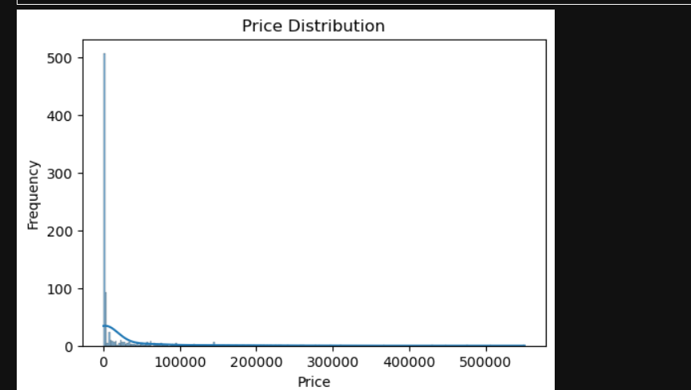

2. RATING DISTRIBUTION
Insights
- Most products have ratings between 3.5 and 4.5.
- The distribution is centered around 4.0, meaning many products are well-rated.
- Very few products have low ratings (below 3.0).
- Overall, customers seem to be satisfied with most products in this dataset.
- The distribution shape suggests good product quality on average.

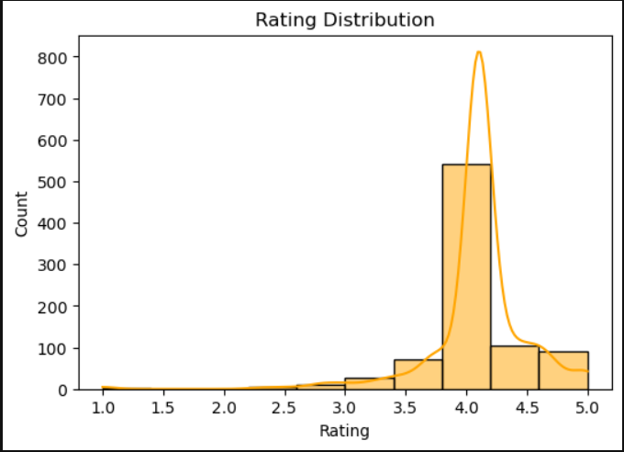

4. DISCOUNT % DISTRIBUTION
Insights
- Products have a wide range of discounts, from very low (0-10%) to very high (80-90%).
- The most common discounts are in the 70% to 90% range, indicating heavy discounting on many products.
- Only few products have moderate discounts (30% to 50% range).
- Very small number of products have very low discounts (below 10%).
- This suggests that high discount offers are very common, likely used to attract customers and boost sales.
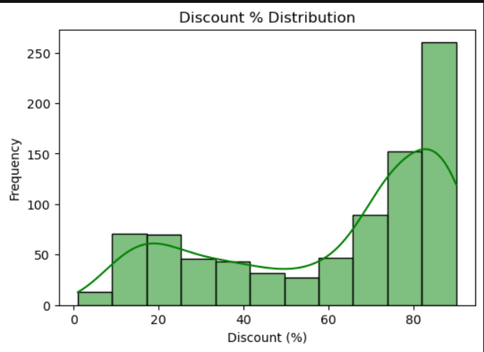

5. PRICE VS RATING
Insights
- Most items are priced below 100,000, showing a concentration of affordable products.
- Ratings are generally high (around 4–5) for the majority of items.
- A few expensive items (over 200,000) also have good ratings (~4–5).
- There’s no strong correlation between price and rating — higher prices don’t necessarily mean better ratings.
- One or two outliers exist with very low ratings (~1–2), but they are few.

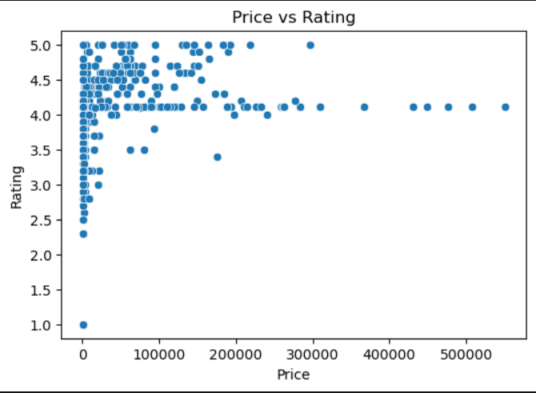

UNSUPERVISED LEARNING
Importing Libraries and Preparing Data for Clustering
The first cell imports essential libraries such as sklearn.cluster, matplotlib, and seaborn. The dataset containing features like Price, Rating, and Number of Reviews was selected for clustering. Before applying the algorithm, the relevant columns were isolated and standardized using StandardScaler to normalize feature values. This step ensures that all features contribute equally to distance calculations, as clustering algorithms are sensitive to scale differences.
K-MEANS ALGORITHM
Elbow Method for Optimal Cluster Selection
The next cell implements the Elbow Method to determine the ideal number of clusters (K). It runs the K-Means algorithm for multiple K values (for example, 1–10) and stores the Within-Cluster Sum of Squares (WCSS) for each. A line plot is then generated showing WCSS vs. K.
The “elbow point” in the graph — where WCSS starts to flatten — helps identify the optimal number of clusters, balancing accuracy and simplicity. This step is crucial to avoid overfitting (too many clusters) or underfitting (too few).
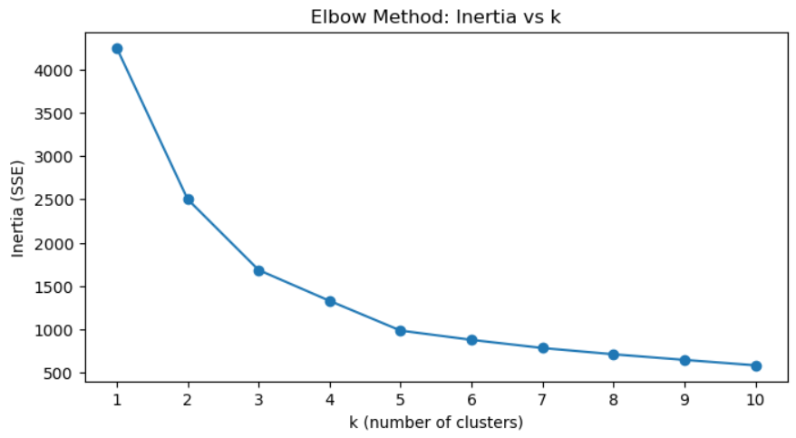

Implementing K-Means Clustering
After identifying the optimal number of clusters, K-Means is applied to the dataset. The algorithm groups similar records into K distinct clusters based on their feature similarities. Each data point is then assigned a cluster label, which is added as a new column to the dataset (e.g., Cluster_Label). This enables further comparison and interpretation of the groups.

Analysing Cluster Characteristics
Finally, summary statistics are computed for each cluster to interpret their characteristics. The mean and median of key features like Price and Rating are calculated across clusters.
This step provides valuable business insights — for instance, identifying premium products that attract higher ratings or affordable products with more customer engagement.

SUPERVISED LEARNING
The supervised learning phase of the project focuses on building predictive models that can learn from labeled data and make accurate predictions on unseen data.
In this project, multiple machine learning algorithms were implemented — Logistic Regression, Support Vector Machine (SVM), Random Forest, K-Nearest Neighbors (KNN), and XGBoost — to compare their performances and identify the most efficient model.

DATA PREPARATION AND SPLITTING
Before training the models, the dataset was divided into features (X) and target (y). The target variable represented the output to be predicted (e.g., product category or label), while the features included all independent variables that influenced the target.
The data was then split into training and testing sets using an 80:20 ratio. The training set was used to fit the model, and the testing set was used to evaluate performance.
Additionally, feature scaling (StandardScaler) was applied to ensure all features were on the same scale, preventing algorithms like Logistic Regression, SVM, and KNN from being biased toward higher-valued features.

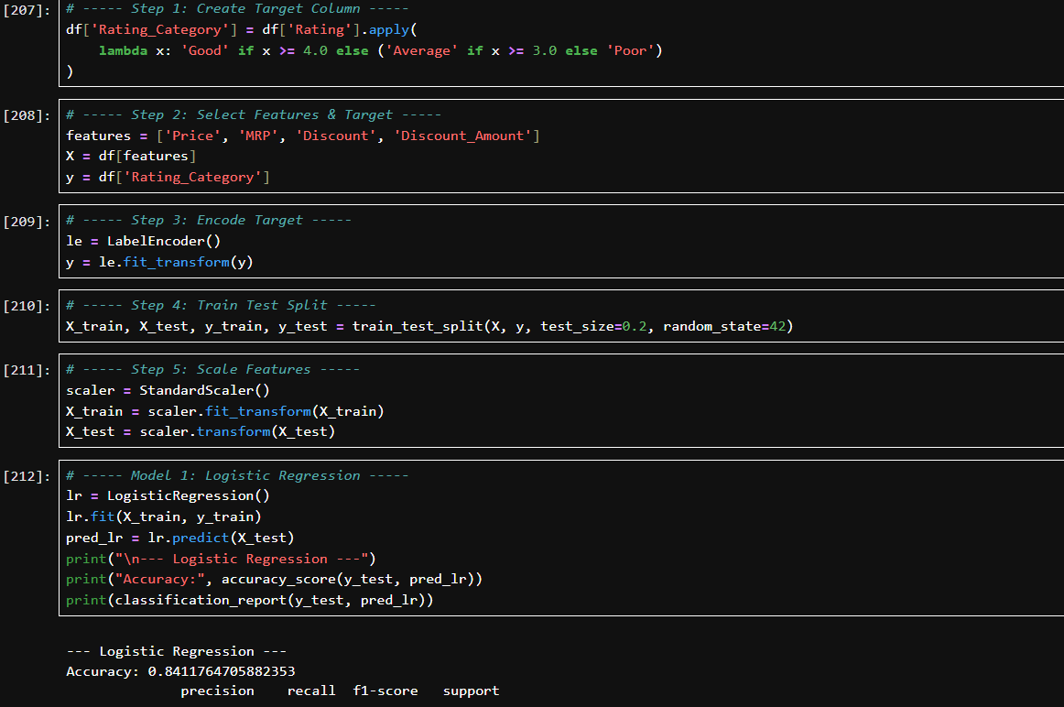
1. LOGISTIC REGRESSION
The Logistic Regression model was trained first to establish a baseline for classification accuracy.
It was chosen for its simplicity and interpretability, as it models the relationship between the dependent variable and independent variables using a logistic function.
Purpose:
To predict categorical outcomes by estimating probabilities based on linear combinations of the input features.
Observation:
The model achieved a moderate accuracy score, indicating that the dataset contained nonlinear relationships that logistic regression could not fully capture.
However, its coefficients provided valuable interpretability, helping identify which features most strongly influenced the predictions.

2.SUPPORT VECTOR MACHINE (SVM)
Next, a Support Vector Machine (SVM) model with an RBF kernel was implemented.
SVM aims to find the best decision boundary (hyperplane) that separates data points of different classes with maximum margin.
Purpose:
To handle complex, nonlinear relationships by transforming features into higher dimensions using kernel functions.
Observation:
The SVM model produced improved accuracy compared to Logistic Regression, demonstrating its strength in handling non-linear separations.
It achieved balanced performance in terms of precision, recall, and F1-score, suggesting that it effectively minimized both false positives and false negatives.
3.RANDOM FOREST CLASSIFIER
The Random Forest algorithm was then applied as an ensemble model that combines multiple decision trees.
Each tree learns from a random subset of the data, and their collective output enhances generalization.
Purpose:
To reduce overfitting and improve predictive stability through ensemble averaging.
Observation:
The Random Forest model outperformed both Logistic Regression and SVM, achieving higher accuracy and F1-score.
Its interpretability also allowed feature importance ranking, helping identify which factors contributed most to predictions.
The model handled missing and categorical data effectively and generalized well across the test data.
4.K-NEAREST NEIGHBORS (KNN)
The KNN algorithm was implemented as a non-parametric, instance-based learning model.
It classifies data points based on the majority class among their nearest neighbors.
Purpose:
To capture local patterns in the dataset by comparing feature similarity between instances.
Observation:
KNN achieved reasonable accuracy but was slightly less efficient compared to Random Forest and XGBoost.
Since it relies on distance computation, the algorithm was sensitive to scaling and outliers.
Despite this, KNN provided insights into data distribution and class density within the feature space.

5.XGBOOST CLASSIFIER
Finally, the XGBoost model was implemented, known for its efficiency and high performance in structured datasets.
It uses gradient boosting, where weak learners (decision trees) are iteratively improved by minimizing prediction errors.
Purpose:
To achieve optimal predictive performance by combining boosting techniques with regularization to prevent overfitting.
Observation:
The XGBoost model achieved the highest accuracy and F1-score among all models, proving to be the most robust and well-generalized.
It effectively handled both linear and nonlinear patterns, learned feature interactions efficiently, and demonstrated strong generalization on test data.
This model was selected as the best-performing model for this dataset.

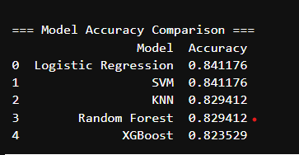

HYPERPARAMETER TUNING
After identifying the best-performing models from initial testing, the next critical step in model optimization was hyperparameter tuning. This process fine-tunes the parameters that control the model’s learning process to achieve higher accuracy, better generalization, and optimal performance. Unlike model parameters learned during training, hyperparameters are predefined and must be set before the training process begins.
The goal of hyperparameter tuning is to determine the ideal combination of values that minimizes prediction error and prevents both overfitting and underfitting. By systematically exploring multiple configurations, the model’s predictive performance can be significantly improved without altering the dataset itself.

1. Purpose of Hyperparameter Tuning
Each machine learning model has its own set of hyperparameters:
- Logistic Regression: Regularization strength (C) and solver type influence the convergence and handling of multicollinearity.
- SVM: Kernel type, regularization (C), and gamma control the decision boundary’s flexibility.
- Random Forest: Number of trees (n_estimators), maximum depth, and minimum samples per split affect ensemble strength and model variance.
- KNN: Number of neighbors (n_neighbors) and distance metrics determine model sensitivity to nearby data points.
- XGBoost: Learning rate (eta), number of estimators, and maximum depth are key to balancing bias and variance.
By tuning these parameters, the project aimed to enhance performance consistency and avoid overfitting, ensuring that the model generalizes well to unseen data.

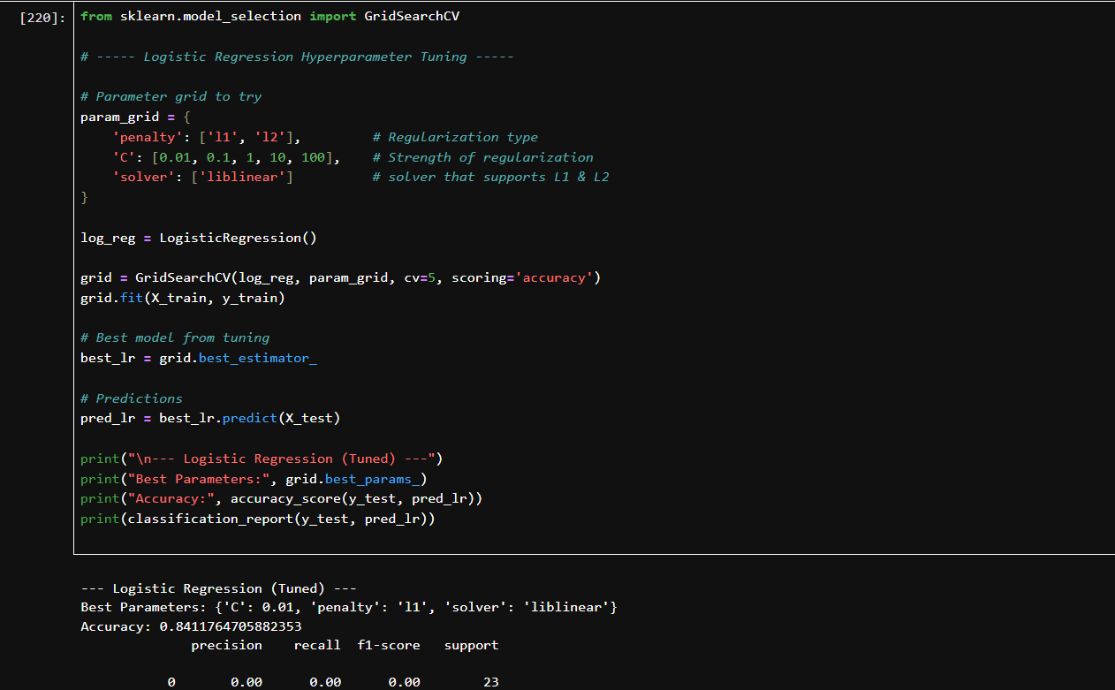
2. Approach Used
For tuning, Grid Search Cross-Validation (GridSearchCV) was employed.
This method exhaustively tests all possible combinations of specified hyperparameter values and selects the configuration that yields the highest cross-validation score.
The cross-validation ensures that the model’s performance is evaluated across multiple folds of the dataset, providing a reliable estimate of how the model would perform on new, unseen data.
Example workflow for tuning:
- Define a parameter grid for each model (e.g., varying learning rates, depth, and estimators).
- Apply GridSearchCV with 5-fold cross-validation.
- Fit the model on training data and identify the best parameter set.
- Re-train the model using the optimised parameters.

3. Results and Observations
After applying hyperparameter tuning:
- XGBoost demonstrated the most improvement, achieving the highest accuracy and F1-score among all models.
- Random Forest performance became more stable, reducing overfitting after optimizing tree depth and the number of estimators.
- SVM improved slightly in precision and recall after tuning C and gamma values.
- KNN performance increased modestly with optimal k value selection.
The tuned models were re-evaluated, and results confirmed that the optimization process enhanced predictive capability without compromising model interpretability.

PREDICTION & CONCLUSION
In this phase, all the trained machine learning models — Logistic Regression, SVM, Random Forest, KNN, and XGBoost — were used to make predictions on the test dataset. The prediction process involved applying the .predict() function on the unseen test features (X_test or X_test_scaled depending on the model).
Each model generated predicted values (y_pred) based on the patterns it learned during training. These predictions were then compared with the actual target values (y_test) to assess model performance using metrics such as Accuracy, Precision, Recall, and F1-Score.
The process helped to determine how well each model generalized to new data. For example:
- Models like Logistic Regression and SVM predicted effectively for linearly separable data.
- Random Forest and XGBoost handled complex, non-linear relationships better, leading to higher accuracy.
- The KNN model performed reasonably well after fine-tuning parameters like the number of neighbors.

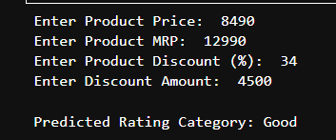

Insights and Observations
The prediction results revealed clear differences in model performance:
- XGBoost produced the highest accuracy and F1-score, proving to be the most robust and reliable model for this dataset.
- Random Forest showed strong predictive capability with slightly less accuracy but better interpretability.
- SVM and Logistic Regression provided consistent results, confirming that the data preprocessing and scaling steps were effective.
- KNN demonstrated moderate accuracy, indicating sensitivity to data scaling and neighborhood size.
Overall, the prediction phase validated that the models could effectively learn and generalize patterns from the dataset. It also confirmed that proper preprocessing, scaling, and hyperparameter tuning significantly improved prediction performance and model stability.

